**Easy ribbed (knitted) poppy pattern.**

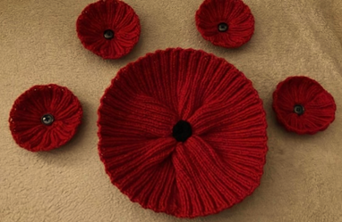

Colour A 1 ball red yarn (this will make a lot of poppies)

Colour B Scrap of black yarn or black button.

4mm knitting needles (old size 8)

**Body of poppy**

Using colour A, cast on 60 stitches

Rows 1-10: K2, P2 across whole row (for a slightly smaller poppy do 8 rows of rib)

Row 11: Knit 2 stitches together across the row (30 stitches)

Row 12: slip 1 stitch. Knit 2 stitches together then pass the slip stitch over – repeat across the whole row (10 stitches)

Break off yarn with long tail and thread back through the remaining stitches and pull tight.

Join edges with mattress stitch.

**Centre of poppy**

Using colour B, cast on 16 stitches.

Cast off.

Coil into a tight spiral and sew base to the centre.

Or use a black or green button with 4 holes and sew to centre of poppy.

Please leave a tail on the wool. *Thank you!*

K = knit; P = purl

**Crocheted Poppies**

You will need some red wool and a black button (or black wool)

1. **Three Petal Crochet Poppy** with 4.5mm hook

Ch 3, join with slst to form circle

Ch3, work 9 dc into the centre of the circle and join with slst.

Work the three petals separately.

Petal 1.

Ch3, work 1st dc into same st. work 2 dc into each of the next 2 sts.

Ch 1 work 2 sc into each st. Tie off.

Petal 2.

Work 2 dc into last dc of previous petal, work 2 dc into each of the next 3 sts.

Ch 1 work 2 sc into each st. tie off

Work petal 3 as 2.

Sew all ends in and attach button in the centre.

*Please leave a tail on the wool. Thank you.*

1. **Two Petal Crochet Poppy** with 3mm hook

Round 1: with 3mm hook and wool, ch2. Make 10 dc in 2nd ch from hook. Join with a slst in 1st dc. (10 sts)

Round 2: *ch1 dc ch1 2tr in next st, 3tr in next st. 2tr ch1 dc in next st, slst in next 2 sts. Rep from * once again.

Round 3: *ch1 3dc in next 2 sts, 2 dc in next 5sts. 3dc in next 2 sts, slst in next 2 sts. Rep from * once again. Fasten off. Attach button in the centre.

*Please leave a tail on the wool. Thank you.*

**Stitch explanation**

ch = chain st(s) = stitch (es)

dc = double crochet rep = repeat

htr = half treble crochet rnd = round

r = row slst = slip stitch

tr = treble crochet